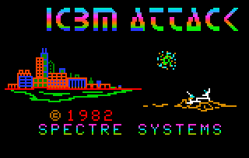
Playing ICBM Attack

Using the MESS Astrocade Emulator

By Paul Thacker and Adam Trionfo
December 28, 2010

Who Can Play ICBM Attack on Real Hardware? Nobody!

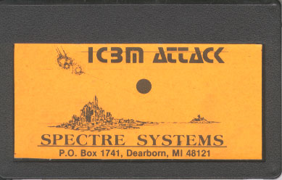
ICBM Attack by Spectre Systems is a third-party game for the Bally Arcade / Astrocade game console. This Missile Command-type game was released in 1982. It is one of the most difficult cartridges to find for the Astrocade system because only about 125 of the games were made.

Besides being extremely rare, there is something else that sets ICBM Attack apart from the rest of the other Astrocade cartridges. The game does not use the regular Astrocade "hand controller" that every other cartridge game uses. Each ICBM Attack cartridge came with an analog controller that is absolutely required to play the game.
The ICBM Attack Cartridge
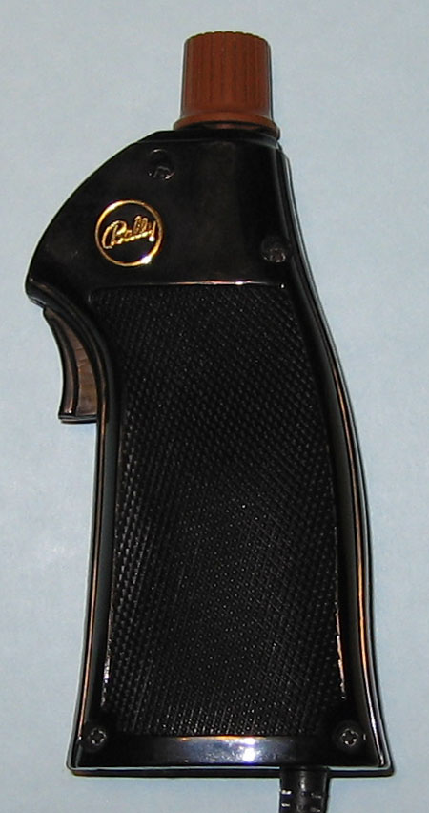
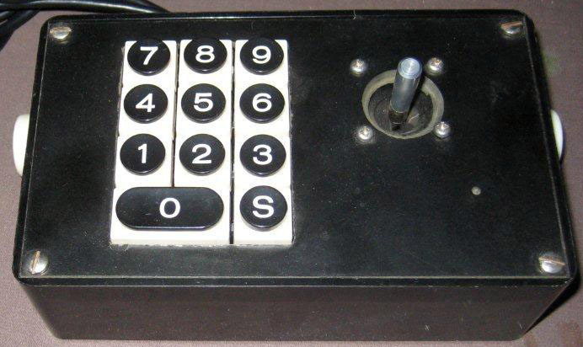
Several of these cartridges have popped up over the years and are in the hands of collectors, but there is only one known instance of anyone owning the controller. Therefore, if anyone wants to play this game (and you should, as it's one of the Astrocade's best games), then ICBM Attack must be played using an emulator.

Starting ICBM Attack

When starting ICBM Attack on a real Bally / Astrocade console the player will be greeted by a black screen when the game is first turned on. In order to start the game the player must press the Reset button, after which ICBM Attack's title screen is displayed. When ICBM Attack is played using the MESS emulator the same thing occurs. Start the game by pressing Soft Reset (F3).
A Regular Astrocade "Hand Controller"
Spectre ICBM Attack Handle
Getting Ready to Set-Up MESS

Using this article you will enable the joystick and/or mouse support in MESS. Also, sometimes there may be trouble with the Windows UI. For this reason, and also to make following this article easier, it is highly recommended that the old interface is used. Here is how to get to the Set-Up options in MESS, select the older interface and activate the joystick and mouse support:
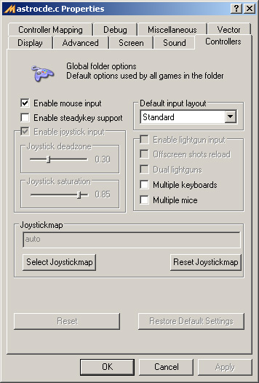
- Enter Set-Up - When running MESSUI, right-click on one of the Astrocade systems. This can be any of the three available systems: Bally Professional Arcade, Bally Computer System or Bally Home Library Computer. Now select "Properties for astrocde.c."

- Use Older Interface - Under the Miscellaneous tab, deselect the "Use New UI" box if it is selected.

- Select Joystick Support - If you plan to use an analog joystick then the joystick needs to be available to the Astrocade. Joystick support is normally selected by default. If not, then under the Controllers tab, select the "Enable Joystick Input."

- Select Mouse Support - If you plan to use a mouse or trackball, then the mouse needs to be available to the Astrocade. Under the Controllers tab, select the "Enable Mouse Input."
Enabling Mouse and Joystick Support

MESS Special Setup

ICBM Attack doesn't use the standard Bally Arcade / Astrocade controller. For MESS this doesn't present a problem at all. This is because the Spectre controller doesn't do anything completely unique. For our purposes it is basically just putting the standard Player 1 and 2 Hand Controllers into a new interface. This makes it possible to easily play ICBM Attack in MESS as long as the controls are mapped correctly. ICBM Attack uses the Player 1 and 2 Hand Controllers like this:

Astrocade Controller Effect
-------------------- ------
Player 1 Knob Moves Crosshairs Left/Right.
Player 2 Knob Moves Crosshair Up/Down.
Player 1 (Left) Fires from the Left Outpost.
Player 1 (Right) Fires from the Right Outpost.
Player 1 (Trigger) Fires from Center Outpost.
Player 2 (Trigger) Starts Game
Any mapping of these controls to different buttons and directions on a mouse or joystick should work. To make the game most playable it is recommended to use an analog controller of some sort such as a joystick, mouse or trackball.

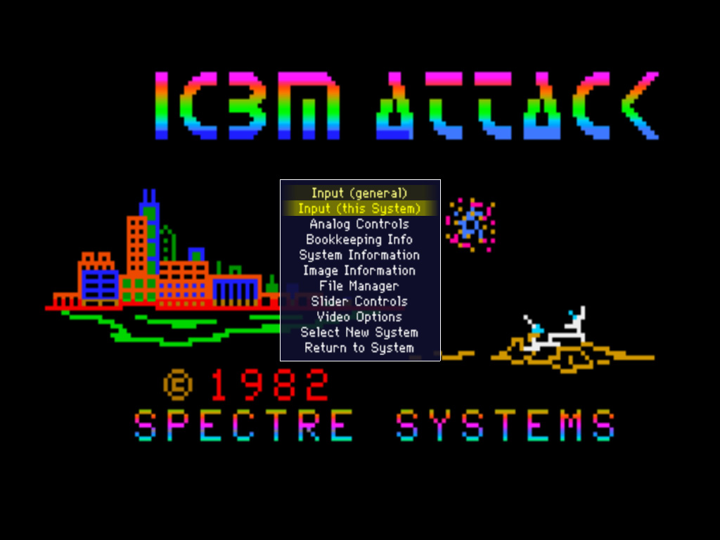
Here is a general overview of how to change input setting for both the joystick and mouse (this is also known as "mapping the controls"):

- Once ICBM attack is started, press Tab.

- Choose "Input (this System)." The buttons and joystick directions are changed here.

- Set the analog paddle controls by choosing "Paddle Analog" or "Paddle 2 Analog" and hitting enter. Now scroll the mouse or push the joystick in the desired direction.

- Set a button by choosing, for example, "P1 Button 1" and then pressing a button on the joystick or mouse.
Pressing Tab brings up the Menu

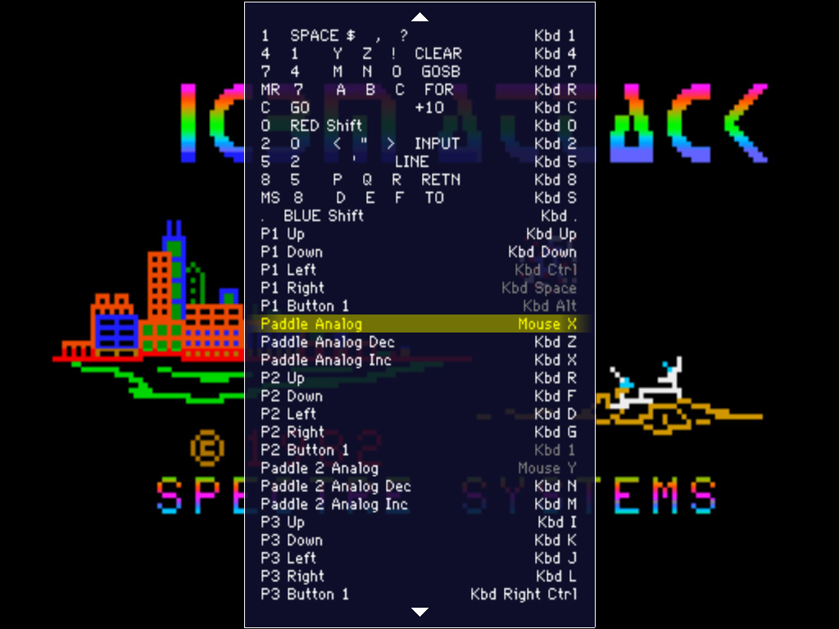
It may be necessary to reverse the direction of the paddles. First try playing the game before you do this step as it may not be needed for your controller. Start the game. If the controller is pressed right but the cursor moves left, then you will need to "Reverse Paddles." This is easy to fix. Using the same steps as above: Press Tab. Choose "Analog Controls." Change the setting for "Paddle Reverse" and/or "Paddle 2 Reverse" to On.

The "Input (this System)" Menu

Analog Joystick Setup

Here, the Xbox 360 controller is mapped as an example of mapping the analog joystick controls of MESS. Setup the controls as follows:

Astrocade Controller XBox 360 Controller Effect
-------------------- ------------------- ------
Paddle 1 Knob Left Analog Stick Move Crosshairs Left/Right
Paddle 2 Knob Right Analog Stick Move Crosshairs Up/Down
Player 1 (Left) Left Bumper Fire from Left Outpost
Player 1 (Right) Right Bumper Fire from Right Outpost
Player 1 (Trigger) Right or Left Trigger Fire from Center Outpost
Player 2 (Trigger) Start Button Starts Game

When mapping the controls, it is very important that you go to analog options and set the auto-center speed on both knobs to 0--otherwise the crosshairs will automatically move back to the upper left. It's possible to map both knobs to a single analog stick, but it seems that that you can't reach the lower-left part of the screen when doing this.

Mouse Setup

Mapping the joystick in MESS emulation works fine to play ICBM Attack-- with one exception: many joysticks auto-center and this makes it very difficult to aim shots. For this reason the mouse works wonders! Here is how a common three-button mouse can be mapped in MESS:

Astrocade Controller Mouse Controller Effect
-------------------- ---------------- ------
Paddle 1 Knob Mouse X Move Crosshairs Left/Right
Paddle 2 Knob Mouse Y Move Crosshairs Up/Down
Player 1 (Left) Left Mouse Button Fire from Left Outpost
Player 1 (Right) Right Mouse Button Fire from Right Outpost
Player 1 (Trigger) Middle/Scroll Mouse Button Fire from Center Outpost
Player 2 (Trigger) Left Control Button Starts Game

ICBM Attack Game-Play Tips

There were never any official instructions for ICBM Attack. If you've ever played Missile Command, then the game-play for Missile Attack will be quite intuitive. Still, here are some tips to help you get started:
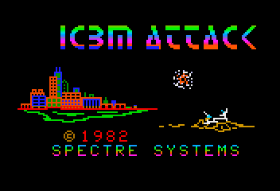

- Try to shoot the enemy ship from whatever outpost is closest.

- You can shoot the bombs to keep them from destroying outposts.

- If an outpost is destroyed then you can't shoot from it anymore.
ICBM Attack's Title Screen
Get Ready for Some Action!
- Each outpost has limited ammunition, so try to conserve your shots.

- At 10,000 points you get awarded another city.

- Sometimes ships will appear on the screen without ever firing a bomb.

- There only seems to be one type of ship, even on the later levels.
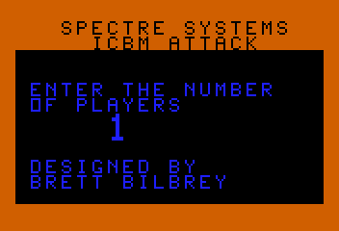
- On later levels the ships move so fast that it seems impossible to hit them, but the bombs/missiles speed only increases a little bit, so concentrate on hitting them.

- Make sure to protect your cities.

- Choosing the correct base to shoot from can make all of the difference between hitting or missing your target.
ICBM Attack supports up to four players.

- You score points for shooting ships, bombs and surviving a level (with more points awarded with the more cities that survive after a level is cleared). The majority of points are scored for surviving a level, with only a few points given for shooting a ship and very few points awarded for destroying a bomb.

- Since so few points are given for shooting a bomb it's best to conserve ammunition and only shoot bombs that will hit a city.

- The ships begin to move very quickly in later levels. Then it becomes quite a feat to hit them. Since surviving a level is worth FAR more points than shooting ships or bombs, you can avoid shooting ships altogether and just shoot the bombs.
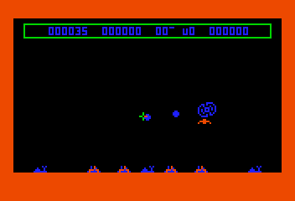
- The player's explosions leave narrow gaps between each "ring" that is a pixel wide. Sometimes an enemy bomb will pass through a player's shot without being destroyed. This is not a bug. To avoid this from happening aim two shots, slightly spread apart, at the enemy bomb. This means using double ammunition, so avoid it when possible. However, when destroying an enemy bomb is absolutely critical for a city to survive this method will work every time.
The Player's Explosion Has a One-Pixel Gap
(See Tip 14)

A Unique Experience

It is likely that you will be very impressed by this game after playing ICBM Attack with an analog device, be it a joystick, mouse, or even a trackball. ICBM Attack will go from being a game that is unplayable because of lack of joystick support to one of the best games in your Astrocade library!

