Identifying the Bally/Astrocade On-Board ROM
--------------------------------------------
By Adam Trionfo

There are at least three different versions of the Bally/Astrocade On-Board ROM. Two models are nick-named after a memory location that yields certain results that make it easy to ascertain which On-Board ROM is being used, while the other is known by the color of the Astrocade itself. These three different versions are:

* 3164 - CALL(3164) yields "Game Over" - Date "1977"
* 3159 - CALL(3164) yields "Over" - Date "1978"
* White Astrocade - Acts like 3159 but says 1977

The reason this matters at all is because of some possible compatibility problems. I know of no cartridges that will not work because of this, but some tape games do have problems because of this. I have not run into any compatibility problems myself, but it is possible that some problems may arise today; knowing which ROM you are using may become important (especially when you are using an actual Astrocade).

Using the following program from the ARCADIAN newsletter (Vol. 5, No. 3, Pg. 49, Jan. 14, 1983) I have been able to identify which version the Astrocade emulator is using:

CLEAR;%(19904)=-43;%(19906)=12341;%(19908)=27651;%(19910)=3164;%(19912)=-13871;CALL19904

After entering this program, the Astrocade looks like fig. 1. When the program is run (after pressing GO), then the screen looks like fig. 2.
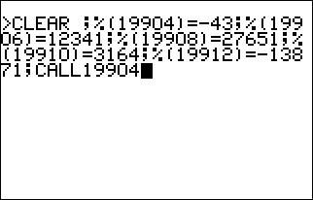
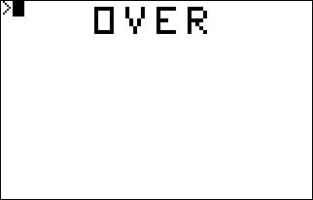
Fig. 1 Fig. 2

This means that the emulator is using the 3159 On-board ROM, which is the most widely distributed ROM.

I'd like to thank Michael White for informing me of the ROM differences with the White Astrocade.

-- August 5, 2001

